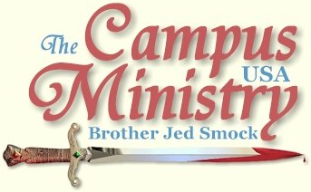
brojed@aol.com
brojed.org
573-999-0346 \
573-999-0346
Below is a report of Bro. Jed's first week back in Missouri. If you would like to help the ministry in some way, there are a list of options at the end of this e-mail. Thanks again to all who prayed for the Atheist/Christian Debate and our Open House. Those exciting details will be in the next journal. In Christ, Sister Cindy
HOME AGAIN
April 4, 2011, Columbia, MO
Martha and I returned home for the first time since January 2. Today was a cold, cloudy and windy day with rain predicted. I decided that I did not want to make my spring debut at Mizzouri on a bad weather day, especially since tomorrow is supposed to be nice. It turned out to be the type of day that if I was on the road I would have preached. But I had things to do to get settled back into home until Sister Pat, Martha and I fly out to the Great NW. on May 8.
ANOTHER DAY AMONG THE SELF-ABSORBED
University of Missouri, April 5, 2011
A man campaigning for public office and a fraternity promoting Autism awareness had occupied Speakers’ Circle when I arrived. I took my place on the circle and started on a lower key than usual. A group of 10-12 gathered as I was more in talking than preaching mode. After an hour I called on Bro Cope who is going to be preaching with Martha and me through the first week of May. Bro spent much of his hour exposing “the fairy tale” of evolution.
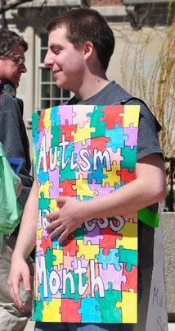
Fraternity Boy Promoting Autism Awareness
By the time it was my turn I decided to say something about this Autism awareness. I said, “We are becoming too aware of Autism.” To me the “disability” is based upon a negative definition of certain social behavior and lack of communication skills. Some children are different and do not develop at the same rate as others. Others were called undisciplined brats. In my youth Autism was unheard of. Of course, there were always those who were different from the rest of us, but that did not mean that they were psychologically disordered or should be labeled Autistic a label that might stick with them for the rest of their lives. These health care professionals want to put this stigma on children, especially boys under three.
As I suspected my comments did not go over well. Nevertheless, I pressed on. Children are having a lot of problems today because they have a mother working outside the home, they are being shuffled off to day care, and many of them do not have a father at home. Drugs and or booze and often pornography are in the home. Plus decadent pop music and degenerate television is constantly blaring in their ears. Plus they are not being taught to be aware of God and his son Jesus Christ. They are not taught to pray, no one reads them the Bible to them and they are not taken to church or Sunday school. Considering the home life of children today no wonder many are not developing as they should!
Someone asked me how I was converted so I seized the opportunity to tell my testimony to a very attentive crowd of perhaps thirty. As I was preaching on other subjects, a group came out promoting a musician, who was going to make an appearance at a local club. They were playing loud decadent music by screamers who obliviously have problems in normal social interaction, communication skills, and cognitive function all of which are “autistic” characteristics. The loud music made it difficult to communicate. I introduced Martha who spoke boldly and did her skit. Afterwards, I was glad to turn the meeting back to Bro as I was tiring of trying to speak above the clamor which is supposed to be music. One of the songs repeated over and over, “F- - - that.”
I could not hear what Bro was saying outside the circle but somehow he was holding the attention of the students despite the noise. A young man started talking to me. I asked him about his Christianity. He said he was saved at 10 years old but just last year got serious with God, when he was “called out.” It turned out that he had been called out by an atheist girl upon whom he was trying to put the make. The atheist said, “You are a Christians you are not supposed to be doing this!” He fell under heavy conviction and went back to his dorm room and prayed through unto salvation. I wonder how many Christian girls would have called him out on this one.
My friend, Rocket, the local musician, arrived. When Bro was done I called upon Rocket. I could not hear much of what he was saying but finally the promoters of the Hell’s bells stopped. Rocket turned it back to me. I had a good session explaining the difference between temptation and sin by telling a few stories on how I have been tempted, which some of the preaching brethren just go into a tizzy when they hear these accounts. Nevertheless, they illustrate my point in a colorful and memorable way. For the last 30 minutes I spoke clearly and compassionately concerning the forgiveness of sins that is available through Christ. It was a very good session. I concluded with prayer at 5:30.
Except for having to deal with the depraved so called music for two hours it was a very good spring debut at Mizzou. Numerous students told the purveyors of the twisted sound to turn it down. “We want to hear Brother Jed,” they said. Sometimes they would do so for a short time but soon they turned it up again.
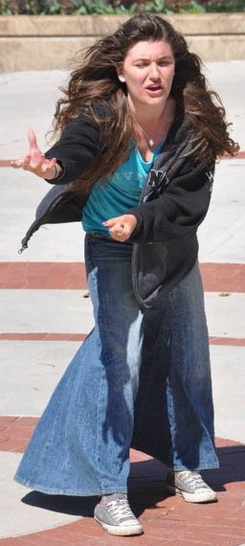
"I introduced Martha who spoke boldly and did her skit."
WE MUST HAVE BEEN DOING SOMETHING WRONG
University of Missouri, April 6, 2011
The autism awareness group was in the Circle again today. One of them asked me, “Do you want to wear a ribbon supporting autism?” “No,” I answered, “I am against autism.”
Also, two dancers doing the tango were in the center of the circle so I started at the edge and gathered a crowd of 25. The female dancer wanted to dance with me. But I informed her I was a married man.
Bro commented at the end of the day, “I must have been doing something wrong the students were just listening, asking few questions and hardly any were arguing.”
I experienced the same lack of opposition. I was lacking in energy on account of fasting today and a short night’s sleep. Martha spoke on the husband being the head of the wife. She always makes a point to say positive things about her dad when she speaks. She thinks I am “awesome.” The students suppose she ought to be embarrassed when I introduce her at “The Virgin, Martha Marie.” She always answer that she is not embarrassed and that she is not on campus because she has to be but because she wants to be.
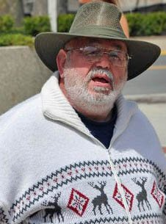
Bro Cope Has Joined Martha and Me For Five Weeks of Preaching In Missouri
Dave Muscato and the atheist club had a table set up with a sign which read, “Ask an Atheist.” They had little action around their table; as usual we were the center of attention. Dave questioned me on many things and took notes. I am going to have to figure out some questions to ask Dave. The problem is that atheism has no answers to the basic questions of life. Evidently, Dave plans on being well-prepared for our debate on April 14 in a large lecture hall in the physics building. I followed up Martha’s remarks concerning the roles of husbands and wives. I also spoke on the root of all sins which is selfishness. In addition I gave a sermon on the 10 Commandments demonstrating that the commandments illustrate what love requires. But Jesus’ life and death fleshes out what the law requires.
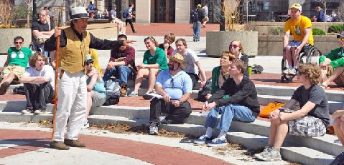
"The Ten Commandments Illustrate what Love Requires..."
HELPING TO SHAPE STUDENTS’ VIEWS
University of Missouri, April 7, 2011
Bro started the meeting. The autism group was still in the area. But there were no significant distractions today. My first message was on the fall of Lucifer and his temptation of Adam and Eve. Rocket spoke for about 30 minutes and students were attentive to his message. When asked, Martha answered that she was going to wait for marriage before she kissed a boy. I was glad to hear that. Martha is strong on speaking that the husband is the head of the house. She said she would not want a house husband or whatever they call the modern husband today.
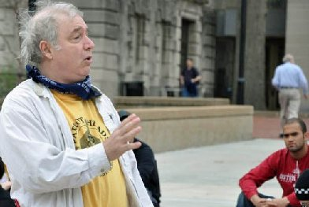
"The Students Were Very Attentive To Rocket's Message." Rocket is a local musician and friend of the ministry.
While Bro was speaking a student said to me, “Although I do not agree with all that you teach, your preaching helps me shape my own views.” I do not remember him ever saying anything in the meetings. I am confident there are a lot like him, who do not participate in the dialogue, but they are weighing everything that is said. Of course, I enjoy those who argue, but I suspect I am reaching more of the silent ones than I realize.
Bro gave his testimony today. He related how he was about to jump out of a high office building, when one of his co-workers invited him to a Bible study. Suddenly, Bro announced to the crowd that he was not going to conclude the story because the students were not listening so he turned the meeting back to me.
The highlight of the day was when Sister Cindy arrived at 4 PM. She always brings great energy. And the size of the crowd usually builds, even as it did today. Normally, crowds will begin to dwindle at 4 PM but she increased the numbers.
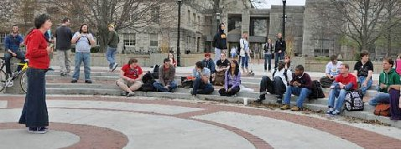
"The highlight of the day was when Sister Cindy arrived at 4 PM."
Bro took over a 5 PM. Martha and I left and Cindy stayed behind while Bro. Bro defended holiness for the next hour. Caleb, a Calvinist, opposed him claiming his was teaching against historical Christianity. Bro stated that the Eastern Orthodox Church believes as he does on overcoming sin. Bro read to him 1 John 3:1-10. Caleb responded, “That is bad exegesis.” Bro exclaimed, “I did not exegete, I just read it!” Cindy and Bro closed the meeting a 6 PM.
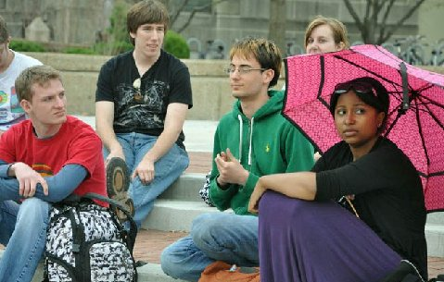
Some of the Regular Listeners
THE LUST GLOVE
University of Missouri, April 8, 2011
A boy and a girl had a table set up in the circle with a sign that read, “ Health Center, Safe Sex=Better Sex, Free Condoms, the Love Glove.”
I went to the MU Student Health Center (which I suppose sponsored the table) website and found the following information: “The SHAPE program helps students understand they own their own body and therefore, must accept responsibility for it by....
...engaging in open and honest COMMUNICATION with their peers about sexual health issues,
...RESPECTING themselves and others by understanding their rights as sexual beings and engaging in non-exploitative relationships,
...promoting and/or using PROTECTION with every sexual act to prevent the transmission of sexually transmitted infections and unintentional pregnancies as well as knowing the physical and emotional effects of sexual intimacy, and
...teaching students to ENJOY their sexuality and their relationships according to their values.
Notice students are to enjoy their sexuality according to their values, not any objective moral standard. Also, note that they are there to encourage students to engage in open and honest communication with their peers concerning sexual issues. On the website there are also “safety” product demonstration videos available to download concerning the male condom, female condom and “the oral dam” at the website. I did not even know about the oral dam. I did not download the videos.
There is a younger generation of open air preachers who oppose my explicit lecture on proper sexual behavior which is only to be expressed within marriage. My lecture is presented in the context of the Christian moral standard using satire to demonstrate the folly of sin. And my talks are far less explicit than the pictures in their textbooks, class videos and lectures.
My critics are fond of quoting Ephesians 5: “11And have no fellowship with the unfruitful works of darkness, but rather reprove them. 12For it is a shame even to speak of those things which are done of them in secret. 13But all things that are reproved are made manifest by the light: for whatsoever doth make manifest is light.”
When I reprove them, some accuse me of being too much in reproof mode. The time to stop reproving is when sinners stop justify their wickedness. Until then, the preacher should be plunging in the sword of the Spirit deeper and deeper. Thus the Scriptural verse which is on my loco reads, “Cursed be he that does the work of the LORD deceitfully, and cursed be he that keeps back his sword from blood.”—Jeremiah 48:10.
It is a shame that I have to teach on these things but these day students are being misguided by those in authority into thinking that anything goes between people who are of age as long as it is consensual. The workers of darkness are unashamedly promoting these things in the open, including the classroom. The Christian point of view must be presented to counteract this perversion. When I speak on these subjects, there are preachers who condemn me as a sinner. I battle sin daily and straightforwardly, while they chant their mantra, “Just preach the gospel.”
I sharply chastened the two students promoting the “Love Glove” (I referred to the rubber as the lust glove), especially the female. I questioned her on what her parents would think if they knew she was advertising condoms. She indicated no shame nor did she claim that her parents would object.
Later some foreign (Asian) businessmen in business suits stopped at the table showing curiosity. I wondered if there would be such an open display in this country.
The first hour I taught on the Lord’s Prayer and the Apostles’ Creed without significant interruption. I asked how many had memorized the Lord’s Prayer. Maybe 15% of the audience had. During a latter session I spoke on the differences between the male and female anatomy and the proper functions of their distinct bodily parts.
A student came into the Circle and informed me that I should not be speaking of these subjects and defended his position by reading Ephesians 5:3, “But fornication, and all uncleanness, or covetousness, let it not be once named among you, as becometh saints.”
He claimed that the verse meant that Christians should not be talking about sex. I explained the verse teaches that Christians should not be engaging in any sexual uncleanness. When Bro took over, I talked with the student on the sidelines. It turns out he just got converted four months ago. He used to heckle me. A Calvinist Church from Kirksville, MO, which comes to campus a few times a year, evidently led him to the Lord. This group does not like me. I asked him if he considered that perhaps I had sown seed into his heart and the Calvinist Church reaped the harvest. He said, “Salvation is all of God. He gets all the glory, not man.” I wonder if he would be consistent and say that damnation is all of God and man is not responsible for his own soul?
Ministry Needs
1. Lots of Prayer
2. Money for a 5 day trip to Southern Missouri this week...gas will be the main expense. Our team will include, Bro. Jed, Martha, Bro Cope, Sis. Pat and Sis. Cindy
3. Safety on the Road and Good Health
4. Wisdom and Anointing
5. Money for the upcoming 5-week trip that Bro. Jed and Martha Marie will make to Oregon and Washington in May. There will be lots of travel expenses!
6. Money for the update of our web site. A friend has our site updated and Martha has added a lot of the journals and pictures from this year. There was an added cost to fix the site.
7. Tell your friends to check out the website.
8. Lots more PRAYER!
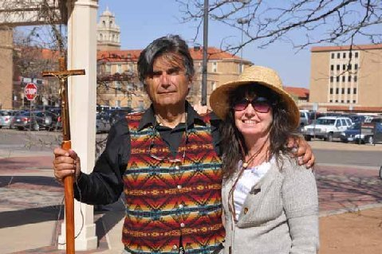
Bro. Jed's Schedule
April 19, University of Central Missouri
April 20-22 Missouri State University
April 25-Truman State
April 26-29 University of Missouri
May 2-5 Southeast Missouri State
May 9 University of Central Washington
May 10-13 Eastern Washington State
May 16-20 University of Washington and Western Washington
May 23-27 University of Oregon
June 31-June 3 University of Washington and Western Washington

Thank you for your faithful prayers and support. Please continue to pray for us. You may donate to CMUSA using PayPal by going to our web site brojed.org or by mailing your check to our home address: CMUSA 2402 Longview Dr. Columbia, MO 65203. All gifts are tax deductible. Thank you for your generosity.

